

Submitted By: Iqra Mushtaq
Reg#: FA24-BBA-119
Class: BBA (B)
Subject: PROGRAMMING LANGUAGE FOR BUSINESS ANALYTICS

Submitted to: SAMEET FATIMA
Department: MANAGEMENT SCIENCES

Question statement: Write a program to check if a number is positive, negative, or zero.
Program:
num = int(input("Enter a number: "))
if num > 0:
print("Positive")
elif num < 0:
print("Negative")
else:
print("Zero")

Output:
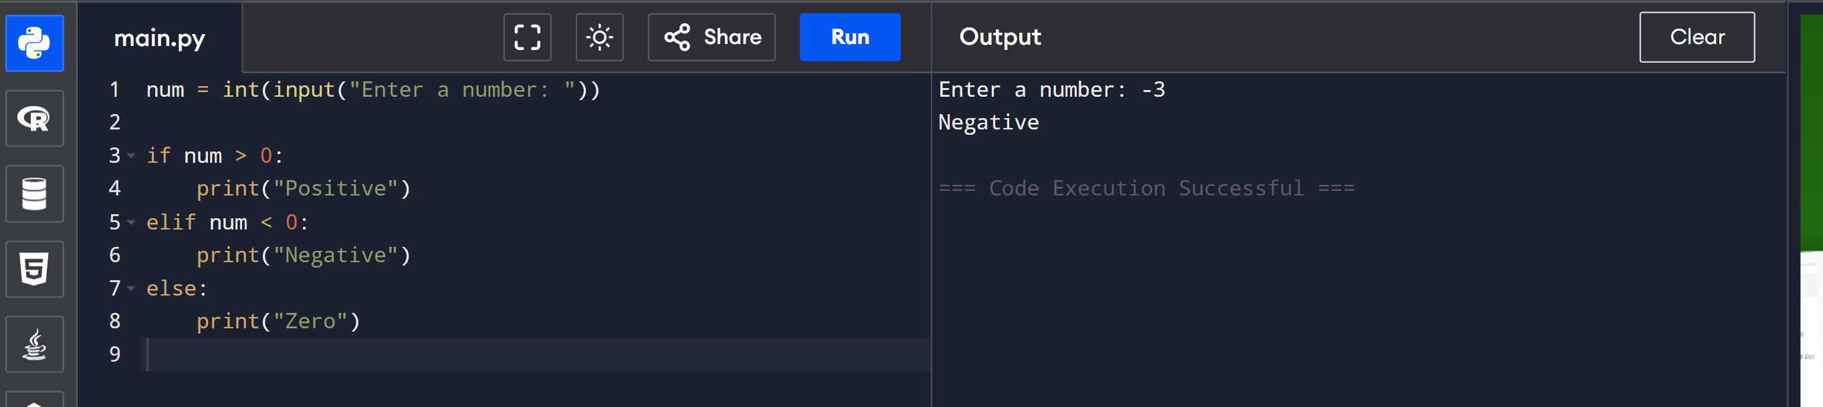
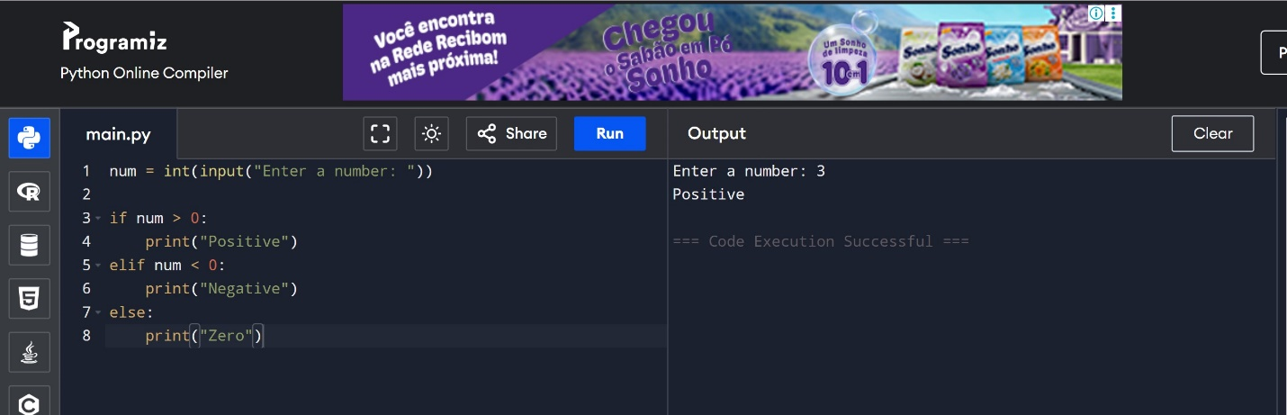
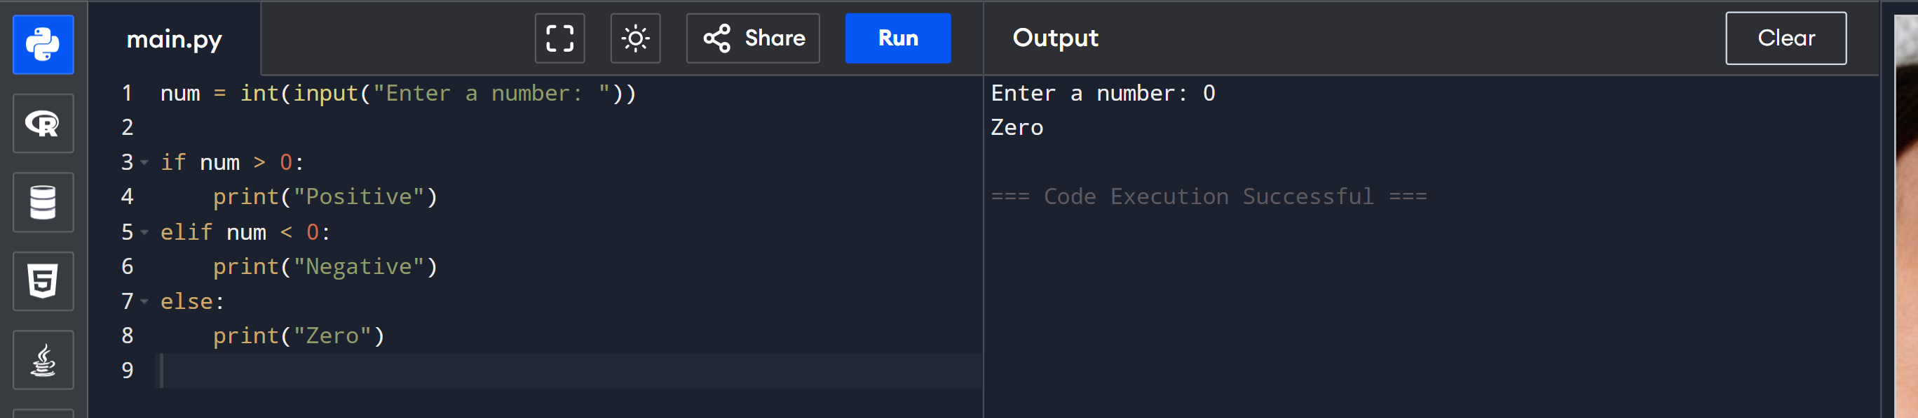

Question 2 Statement: Create a program to determine whether a given year is a leap year.
Program:

year = int(input("Enter a year: "))
if (year % 4 == 0 and year % 100 != 0) or (year % 400 == 0):
print("Leap year")
else:
print("Not a leap year")

Output
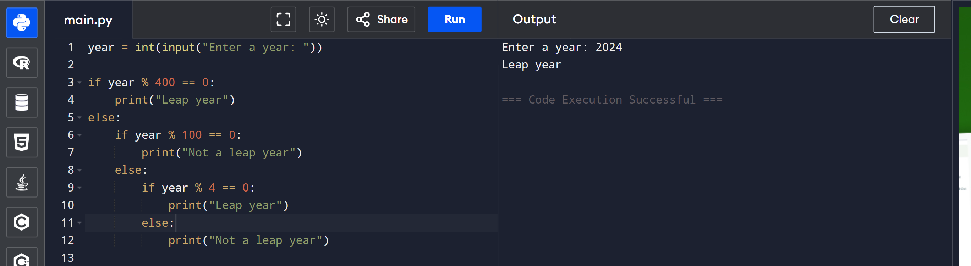
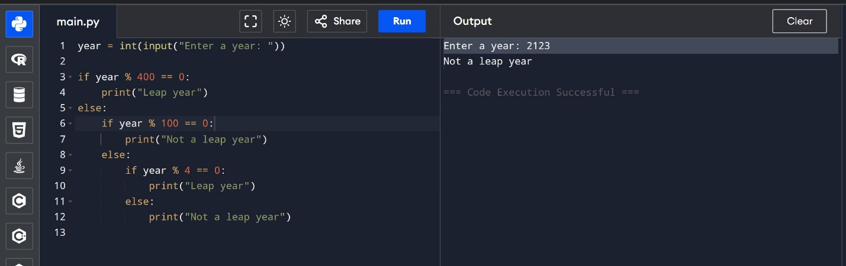
Question 3 Statement: Build a simple calculator that asks for two numbers and an operator (+, -, , /) and prints the result.
Program:
num1 = float(input("Enter first number: "))
num2 = float(input("Enter second number: "))
op = input("Enter operator (+, -, *, /): ")

if op == "+":
print("Result:", num1 + num2)
elif op == "-":
print("Result:", num1 - num2)
elif op == "*":
print("Result:", num1 * num2)
elif op == "/":
if num2 != 0:
print("Result:", num1 / num2)
else:
print("Division by zero not allowed")
else:
print("Invalid operator")
Output
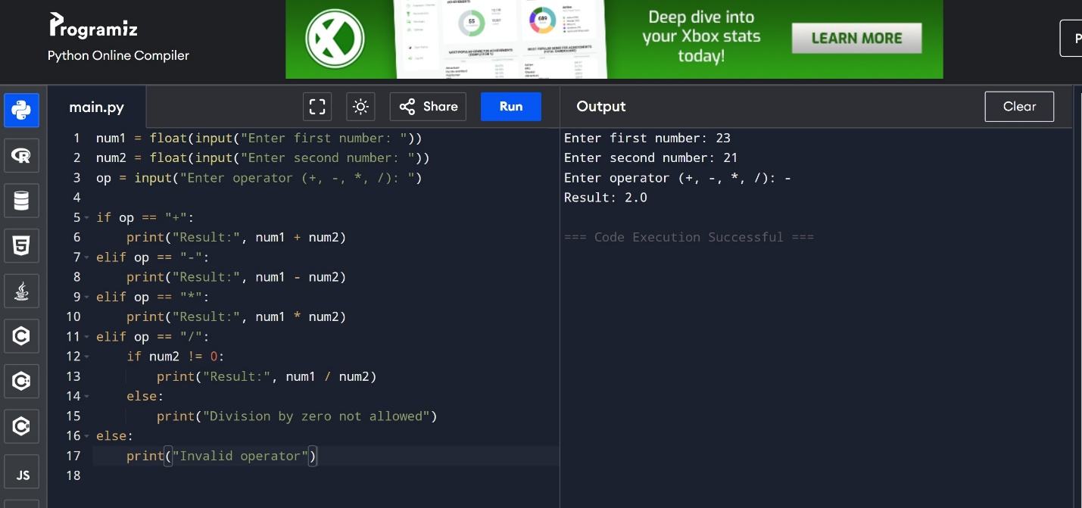
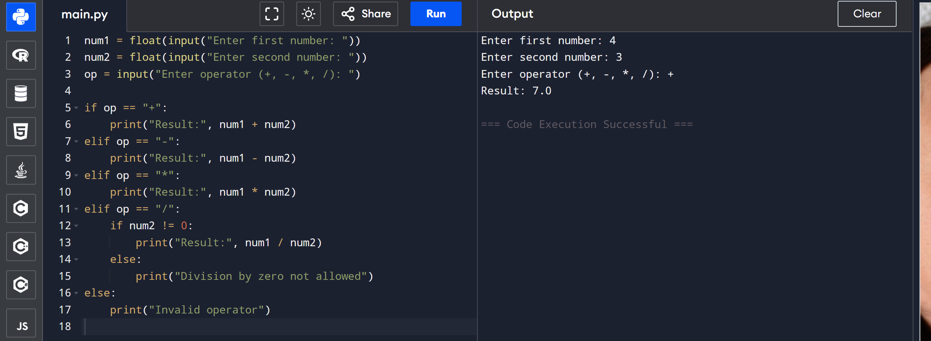

Question 4 Statement: Write a Python program that accepts a student's marks and prints the grade (A, B, C, F).
Program:
marks = int(input("Enter student's marks: "))

if marks >= 85:
print("Grade: A")
elif marks >= 70:
print("Grade: B")
elif marks >= 50:
print("Grade: C")
else:
print("Grade: F")
Output
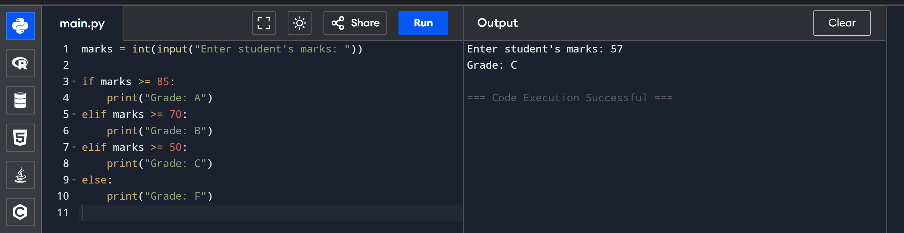
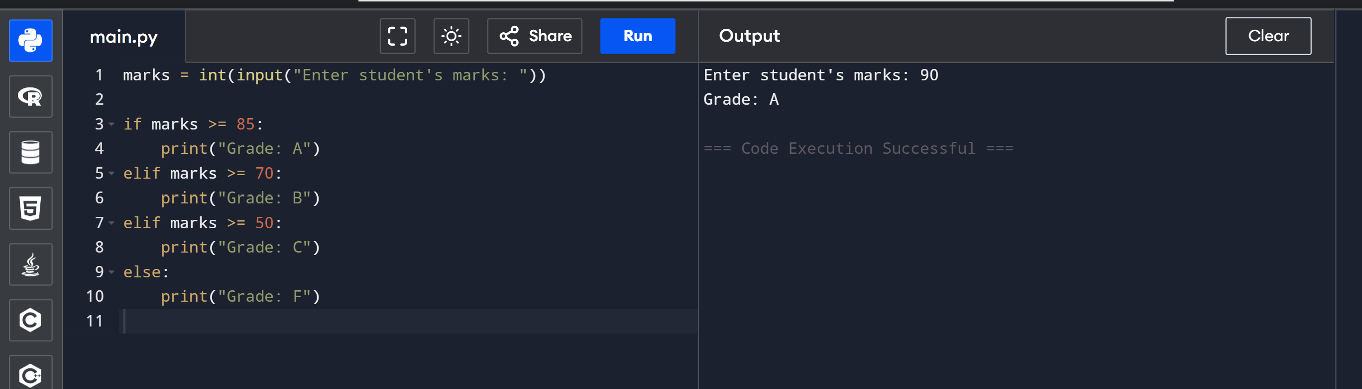

Class Activity (Task)
Plan a weekend getaway to Murree, applying the four pillars of computational thinking: decomposition, pattern recognition, abstraction, and algorithm design. Document your planning process in your notebook.

Q1: How can you break down the trip planning process into smaller, managable tasks?
I can divide the trip into tasks like: deciding travel dates, arranging trasnport, booking hotel, planning meals, creating an activity schedule, managing budget, and packing essentials.

Q2: What patterns can you identify from your past travel experinces?
From past trips, I noticed patterns like overspending when not budgeting, wasting time when no schedule was made, and forgetting essentials when packing last minute. Having bookings and a checklist always makes the trip smoother.

Q3: What are the essential elemnts to consider when planning a trip?
Important elements are budget, transport, accommodation, safety, weather, places to visit, and time management. Also keeping alternatives in case of unexpected issues.

Q4: How can you create a step-by-step plan to ensure a successful trip?
- Fix the date and duration.
- Decide budget and number of people.
- Book transport and hotel in advance.
- Make a list of must-visit spots in Murree.
- Plan meals and small activites.
- Pack clothes and essentials according to weather.
- Keep emergency cash and contacts.
- Follow the plan but stay flexible.

